Self Service AdTech Integration

Requirement Specifications

esm_logo.jpg

Nexelus USA  
New York, NEW YORK (NY)  
646-558-1950 ext.128

**7/30/2025**

## Document Information

The following table shows the details for document creation, review, approval, and effective date.

| **Category** | **Information** |
| --- | --- |
| Work Product: | Self Service AdTech Integration – Requirement Specifications |
| Project Name: | Security Manual |
| Function Name: | Requirement Specifications |
| Version: | 0.1 |
| Status: | Draft |
| Author(s): | Tauseef Shahzad |
| Reviewer(s): | Asim Jameel |
| Approver(s): | Imran Rahman |
| Control Status: | CONTROLLED, PROTECTED |
| Disclaimer: | This document contains confidential information. Do not distribute this document without prior approval from Nexelus. |

## Revision History

The following table is used for revision details of this document.

| **Author(s)** | **Date** | **Version** | **Description of Change** |
| --- | --- | --- | --- |
| Tauseef Shahzad | July 30, 2025 | 0.1 | Initial Draft |

## Table of Contents

Contents

[Document Information ii](#_Toc204778993)

[Revision History iii](#_Toc204778994)

[Table of Contents i](#_Toc204778995)

[Scope 1](#_Toc204778996)

[Proposed Solution 1](#_Toc204778997)

[IPC Configuration Portal 2](#_Toc204778998)

[Add Tool 3](#_Toc204778999)

[User Interface 3](#_Toc204779000)

[Database Tables 4](#_Toc204779001)

[Consumer 6](#_Toc204779002)

[User Interface: 6](#_Toc204779003)

[Database Tables 7](#_Toc204779004)

[Consumer Account 8](#_Toc204779005)

[User Interface 8](#_Toc204779006)

[Database Tables 8](#_Toc204779007)

[Ad Tool Configuration 10](#_Toc204779008)

[User Interface 10](#_Toc204779009)

[Database Tables 15](#_Toc204779010)

## Scope

Nexelus has implemented an extensible, pluggable integration system for AdTech platforms. Google Ads, Google DV360, Microsoft Ads, Yahoo, TradeDesk, LinkedIn and some AdTech platforms have been integrated with Nexelus using this architecture.

The mechanism for configuration and enabling these AdTech Plugins is manual and requires continuous back and forth communication with clients. It also requires direct Database access to execute SQL scripts for plugin integration and to enable these plugins for specific clients. This process not only delays the integration process, but it also causes frustration for the client.

### Proposed Solution

The scope of this document is to provide specifications for a self-serviceportal forallintegrations which will allow:

* Nexelus to configure AdTech Plugins with IPC
* Clients configure all AdTech configurations themselves without requiring extensive involvement of Nexelus resource.

The Portal will also provide health checker services for integrations by providing real time information about health of integrations (integrations include both, Pushing of Campaign / IO/ BO and pulling of delivery).

## IPC Configuration Portal

IPC Portal will be designed for both Portal Administrators and Clients. The following features will be available for Administrators only.

* Ad Tool integration
* Define new clients (Consumers)
* Add/Manage portal users against each client

The client will be able to perform the following task:

* Consumer Accounts
* Ad-Tech configurations
* Authorized Account Users

## Add Tool

Ad Tool is an integration of an AdTech service with IPC Service. Each Ad tool needs to be configured separately.

### User Interface

1. A Tool Listing

Clicking on an Ad Tool name on Listing UI, will show Ad Tool UI in Edit mode.

1. Ad Tool Configuration

**Note:** Installation of plugin is out of scope for this document. The portal only configures the installed plugins.

1. Ad Tool Configuration Fields

### Database Tables

#### Table: pdim\_ad\_tool

Ad Tool Plugin reference is created in this table

|  |  |  |
| --- | --- | --- |
| **Field** | **Type** | **Description** |
| ad\_tool\_id | int | Foreign Key |
| orig\_name | nvarchar | Ad Tool Name |
| orig\_version | nvarchar | Ad Tool Version |
| ipc\_name | nvarchar | Ad Tool IPC Name |
| ipc\_description | nvarchar | Ad Tool IPC Description |
| ad\_tool\_category | int | Ad Tool Category |
| is\_active | tinyint | Is Active |
| ipc\_connector\_dll\_name | nvarchar | DLL Path relative to IPC Setup |
| ipc\_connector\_dll\_description | nvarchar | DLL Descriptive Name |
| ipc\_connector\_dll\_is\_active | tinyint | Is DLL Active |
| ipc\_connector\_dll\_version | nvarchar | DLL Version |
| ipc\_connector\_dll\_release\_date | datetime | DLL Release Date |

#### Table: pdim\_ad\_tool\_api\_access

Fields required to configure Ad Tool are defined in this table

|  |  |  |
| --- | --- | --- |
| **Field** | **Type** | **Description** |
| ad\_tool\_id | int | Foreign Key |
| api\_access\_property\_id | int | Unique row identifier |
| display\_order | int | Display order for the field |
| label | nvarchar | Field Label |
| help\_description | nvarchar | Help Description |
| is\_required | tinyint | Is a required field |

## Consumer

Each Nexleus client is assigned a unique Consumer ID within the IPC system. This Consumer ID is consistent across all companies operating under the same Nexleus instance.

The Consumer table below outlines the assignment process. The initial step in the IPC integration workflow involves creating an entry in the Consumer table to allocate a Consumer ID to the respective Nexleus client.

Note: This is a one-time setup per company. If a Consumer ID has already been assigned to a Nexleus client, it must be reused for any subsequent configurations—new IDs should not be created.

### User Interface:

1. IPC Consumer Listing

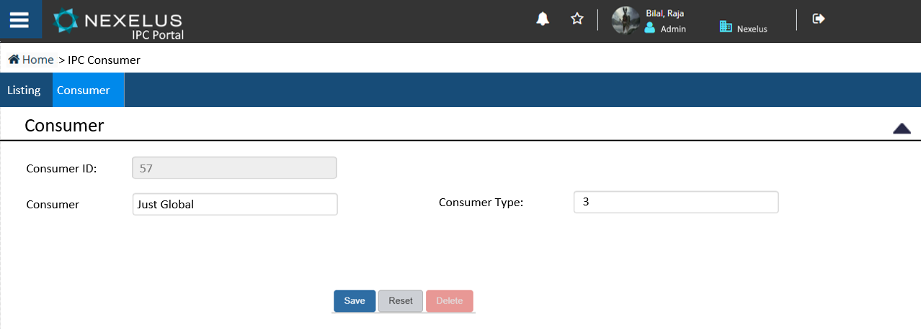

1. Consumer Editing

### Database Tables

#### Table: PDM\_CONSUMER

|  |  |  |
| --- | --- | --- |
| **Field** | **Type** | **Description** |
| consumer\_id | int | Primary Key |
| name | nvarchar | Consumer Name |
| consumer\_type\_id | tinyint | Type of consumer indicates if it is internal client or external, currently we have only internal consumer whose value is 3. use 3 for Nexelus clients |

## Consumer Account

Consumer Account is a set of configurations of multiple Ad tools for use in Nexelus. Multiple accounts may be configured against a consumer/client.

### User Interface

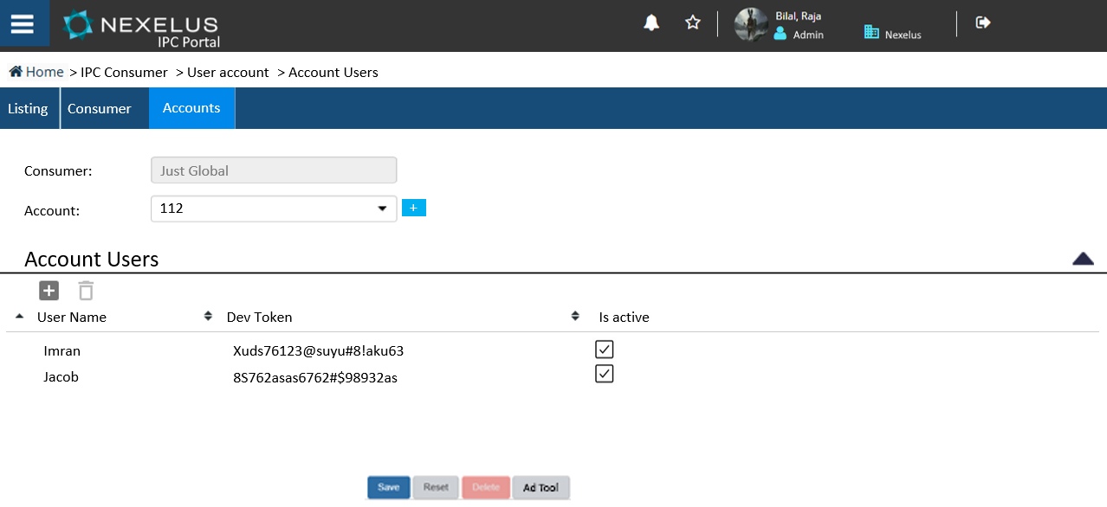

Note: Listing and Consumer Tab will be visible only for Admin users. For standard users, only Accounts tab will be visible.

### Database Tables

#### Table: PDM\_CONSUMER\_ACCOUNT

|  |  |  |
| --- | --- | --- |
| **Field** | **Type** | **Description** |
| account\_id | Varchar(128) | Account ID for new client |
| Consumer\_id | Int | Foreign key |
| Eff\_date | Datetime | Current date |
| Exp\_date | Datetime | Future date when account will expire |

#### Table:  PDM\_ACCOUNT\_USER

|  |  |  |
| --- | --- | --- |
| **Field** | **Type** | **Description** |
| account\_id | Varchar(128) | Foreign key |
| user\_id | nVarchar | Unique id |
| user\_name | nVarchar | Current date |
| Password | nVarchar | Future date when account will expire. |
| is\_active | Tinyint |  |
| dev\_token | Varchar(256) | 333 for now for all entries. |

## Ad Tool Configuration

Each Ad Tool is configured separately for client usage

### User Interface

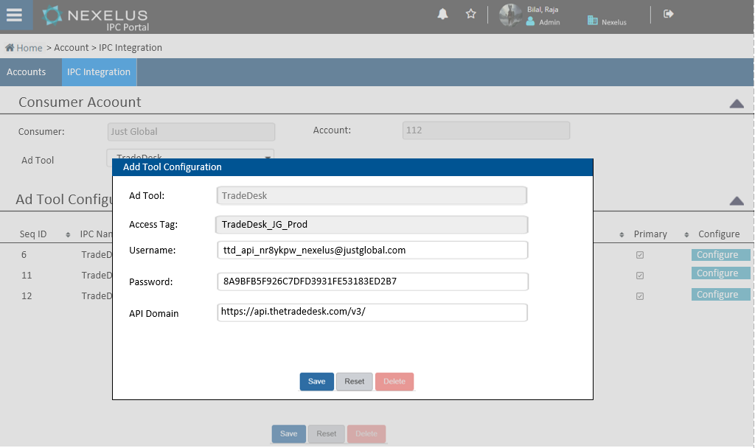

For each Ad Tool different fields are required. Fields defined for different Ad Tools are given below:

#### Google Ads

Following information are required in IPC to integration Google Ads

1. **Budget Order Creation  
     
   a. UI Integration**

|  |  |  |
| --- | --- | --- |
| Entity | Description | API\_access\_property\_id |
| App Name |  | 1 |
| **Developer token** |  | 2 |
| **Mcc** |  | 3 |
| **Email Address** |  | 4 |
| **Client Secret** |  | 5 |
| **Client ID** |  | 6 |
| **Access Token** |  | 7 |
| **Refresh Token** |  | 8 |

1. **Delivery**
2. **GCM**
   1. **UI integration**

|  |  |  |
| --- | --- | --- |
| Entity | Description | API\_access\_property\_id |
| App Name |  | 1 |
| Access\_token |  | 10 |
| Refresh\_token |  | 11 |
| File store path |  | 13 |
| Profile id |  | 14 |

* 1. **Delivery Pull**
     1. **Report ID**

1. **DV360**
   1. **UI Integration**

|  |  |  |
| --- | --- | --- |
| Entity | Description | API\_access\_property\_id |
| App Name |  | 1 |
| Access\_token |  | 10 |
| Refresh\_token |  | 11 |
| File store path |  | 13 |
| Profile id |  | 14 |

* 2. **Delivery**
     1. **Report ID**

1. **Microsoft Advertising**
   1. **UI Integration**

|  |  |  |
| --- | --- | --- |
| Entity | Description | API\_access\_property\_id |
| Dev Token |  | 2 |
| Master Account |  | 3 |
| Refresh\_token |  | 10 |
| Access token |  | 12 |
| Store path |  | 13 |

* 1. **Delivery**
     1. **Report ID**

1. **TheTradeDesk**
   1. **UI Integration**

|  |  |  |
| --- | --- | --- |
| Entity | Description | API\_access\_property\_id |
| App Name |  | 1 |
| Access\_token |  | 10 |
| Refresh\_token |  | 11 |
| File store path |  | 13 |
| Profile id |  | 14 |

* 1. **Delivery** 
     1. **Schedule ID**

1. **Yahoo**
   1. **UI Integration**

|  |  |  |
| --- | --- | --- |
| Entity | Description | API\_access\_property\_id |
| App Name |  | 1 |
| Access\_token |  | 10 |
| Refresh\_token |  | 11 |
| File store path |  | 13 |
| Profile id |  | 14 |

* 1. **Delivery**
     1. **Report ID**

1. **LinkedIn**
   1. **UI Integration**

|  |  |  |
| --- | --- | --- |
| Entity | Description | API\_access\_property\_id |
| App Name |  | 1 |
| Access\_token |  | 10 |
| Refresh\_token |  | 11 |
| File store path |  | 13 |
| Profile id |  | 14 |

* 1. **Delivery**
     1. **Report ID**

1. **Twitter**
   1. **UI Integration**

|  |  |  |
| --- | --- | --- |
| Entity | Description | API\_access\_property\_id |
| App Name |  | 1 |
| Access\_token |  | 10 |
| Refresh\_token |  | 11 |
| File store path |  | 13 |
| Profile id |  | 14 |

* 1. **Delivery**
     1. **Report ID**

1. **FaceBook**
   1. **UI Integration**

|  |  |  |
| --- | --- | --- |
| Entity | Description | API\_access\_property\_id |
| App Name |  | 1 |
| Access\_token |  | 10 |
| Refresh\_token |  | 11 |
| File store path |  | 13 |
| Profile id |  | 14 |

* 1. **Delivery**

**Report ID**

### Database Tables

#### Table: PDM\_ACCOUNT\_USER\_AD\_TOOL

|  |  |  |
| --- | --- | --- |
| **Field** | **Type** | **Description** |
| account\_id | Varchar(128) | Foreign key |
| ad\_tool\_id | int | Id of adtool, this is predefined id for each adtool. Please ceck adtool id lists for this Entery |
| seq\_id | int | Incremental Seq id assigned to this record, for each tool , it starts with 1 |
| user\_id | Varchar | Foreign key from pdm\_account\_user table. |

#### Table: pdm\_account\_ad\_tool

|  |  |  |
| --- | --- | --- |
| **Field** | **Type** | **Description** |
| account\_id | Varchar(128) | Foreign key |
| ad\_tool\_id | Int | Id of adtool, this is predefined id for each adtool. Please see section “c” above for ids. |
| seq\_id | Int | Incremental Seq id assigned to this record, for each tool , it starts with 1 |
| access\_tag | narchar(256) | Foreign key from pdm\_account\_user table. |
| ipc\_name | Nvarchar(256) |  |
| Eff\_date | Datetime |  |
| Exp\_date | Datetime |  |